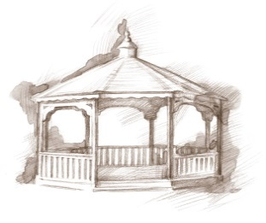TheVillageVoice

**June 2020**

Westminster Resident Spotlight

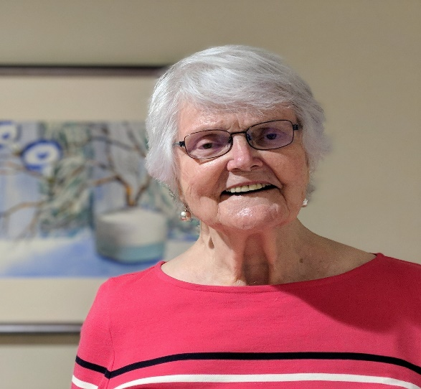*I began my graduate work at BSU in Health Education and Public Health with an emphasis in Gerontology. One of the things I learned was how important it was for elders to plan for their own futures and not leave it up to their children. So at some point, when my husband Hal’s physical health was failing, I began talking about moving to Westminster Village, as I only wanted to move once. Finally, one evening, Hal said it was time to go. I asked him, “go where?” and he said, “Westminster!” The* next *morning I called Westminster for a tour, apartment selection, and our realtor. We moved into Westminster in 2012. Unfortunately, Hal died within 6 months of our move, from a bad fall, but though I miss him so much, I knew he was no longer in such terrible pain! I have been at Westminster for 8 years and love it! I love the security and my lovely apartment. I love knowing that my children have less worry about me and I love knowing that if or when I get sick, the Health Care or Rehab is nearby. I love the evening classical music performances. I love having friends nearby, even though we can’t be close at this moment! To quote my children, both of whom are physicians, Janet, my older child who lives nearby, says, “she knows there is someone here at all times who can help me and she trusts that they will let her know if something is wrong!” My son, Doug, says “he is happy that I’m happy,” and I am! Thank you to all who make Westminster Village so comfortable and safe!*

Judith Roepke was born in Winnipeg, Manitoba Canada. She graduated from the University of Manitoba with a BS. Judith married Harlan H. Roepke in 1958 and moved to New Alexandria, Virginia, where she worked at the Alexandria Hospital. She became an American Citizen in 1967, the same year she started her graduate work on a Masters of Science at Ball State, in Muncie. She completed her PhD in Nutrition with a minor in Physiology in 1977 and returned to teaching full time at BSU. Judith is the Treasurer and Acting Secretary of Westminster’s Resident Association.



New Cygnets Have Hatched!

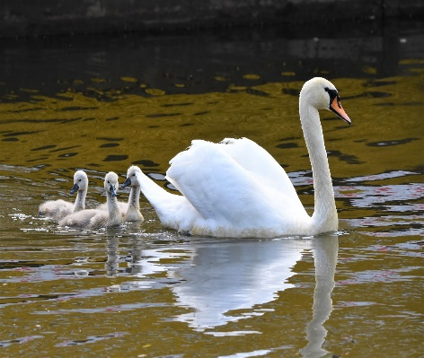On Friday, May 15th, three baby swans, known as cygnets, hatched, next to the Westminster pond. It doesn’t take the cygnets long to start paddling around with their mother. Our swans are Mute Swans and the male and female pair mate for life. Their names are Victoria and Albert, named by the residents in 2007 in a contest. They are approximately 20 years old, purchased locally. The swan logo was created in 2014 for Westminster.

A Quilt Made With Love

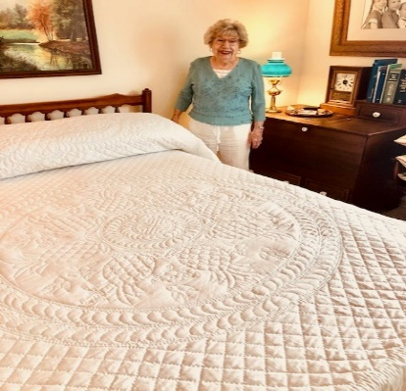These last few months many of Westminster’s residents have been finding creative ways to stay busy as they find themselves in their apartments for longer periods of time. Emma Lee Slagle, who is in charge of our Next-to-New Shoppe, decided to spend her time hand stitching a quilt. She purchased the quilt kit 20-30 years ago but didn’t start it until 4 years ago, when her friend, Mary Jo Weber, encouraged her to begin. When Mary Jo passed, Emma Lee put the quilt away. She decided to bring it out in January to give her a winter project. She worked on it every day and it took her 5 months to complete. It is truly a beautiful piece of work!

Wishing Gay Nation

The Very Best!

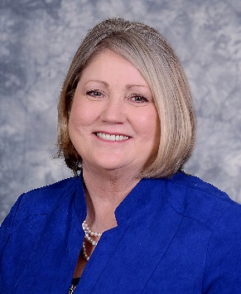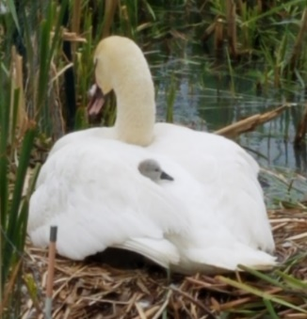Congratulations to Gay Nation, Marketing Director, on her retirement from Westminster Village! We are genuinely wishing her the very best as she enters into the next phase of life – pursuing her passion for art in the Brinkman Gallery. Good luck Gay!

Please like our Facebook page, *Westminster Village Muncie*, for all of our updates. Be sure to visit our website wvmuncie.com. Also, call Tyler or Melody to schedule a 360° Virtual Tour and receive a gift!

5801 W. Bethel Avenue,

Muncie, IN 47304

765-288-2155

If you would like to opt out of this newsletter, please call Melody at

765-288-2155, or email [hhaskell@wvmuncie.com](mailto:hhaskell@wvmuncie.com).