Westminster Village Resident Spotlight

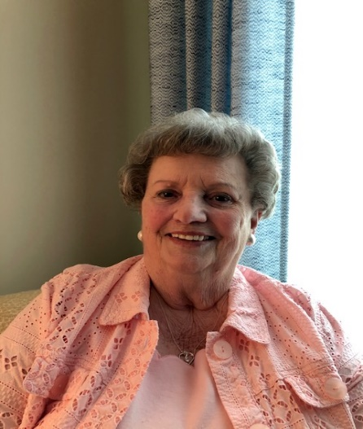*“After driving past Westminster Village almost daily for over eleven years, then spending a month in rehab at Westminster’s CooperVista, I knew where I wanted to spend my remaining years. This is one of the most beautiful campuses you’ll find anywhere. I love the staff, the way they take care of all my needs. I don’t have to worry anymore whose going to take care of “what” or “when.” I just call the Front Desk, they send someone up to take care of it. After being here over a year and a half, I can’t be more pleased than I am right now, sitting here at my desk; in my nice cozy apartment, with my morning coffee and the sun coming in my windows, what more could I ask for? I am secure, well fed, and everyone is very friendly. I even mention my love for Westminster on my Facebook page. There truly is something for everyone. Come, join our family. I think you’ll like it!”*

**Carol Salian** was born and raised in Delaware County, graduating from Gaston High School. She spent most of her adult life in California, attending Moorpark and Ventura Colleges. She returned “home” in 2007. She says, “once a Hoosier, always a Hoosier!” After Carol’s husband, Jack, passed away, and she was no longer a Real Estate Broker, she felt that she wanted to be near family, so Carol moved back to Muncie.



CCRC: Myth vs Fact

**Myth:** “I’m too young to live with “old people”!

**Fact:** Age is just a number. There is no magic age when it comes to choosing a senior living community. When the subject comes up at Westminster Village, many residents say that they wished they had made the move when they were younger. They are busier and more active at Westminster than they were living at home due to having more opportunities at hand. The culture at Westminster Village is a diverse mix of people. It includes residents living in Independent apartments, residents living in Assisted Living apartments, staff members, family and friends visiting and many community members who stop by weekly for activities. It’s not a place for “old people.” It’s a hub of activity and fun for all ages.

Westminster’s New Swans

On August 12th, our twenty year old swan pair, Albert and Victoria, the original Westminster Village Mute Swans, retired to a lake in northern Indiana. A new set of Mute Swans are now on Westminster’s pond. They came from the same lake in northern Indiana. The new male (the Cob) is originally one of the cygnets from Albert and Victoria, keeping the legacy going. He is seven years old. The female (the Pen) is the new male’s lifetime mate. They had six cygnets this season and they are still on the lake in northern Indiana. Both birds will take time to acclimate to their new surroundings and getting used to being around people. The swans are fed grain each day by our Maintenance Department. Residents, staff, and visitors often give them special treats of popcorn, crackers and bread. The swans live on the pond year round, as they adapt to the weather. Westminster residents are currently deciding what to name the new swan pair.

Safe & Warm at

Westminster Village

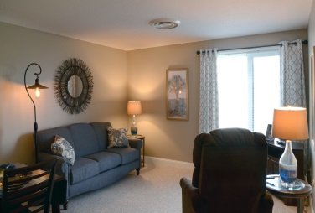Does the thought of spending another winter at home alone, concern you? Consider spending those cold winter months at Westminster! Where you may be able to live for less, enjoying a *Life in Balance*. Just pack your bags and move into one of our furnished apartments. Shop in our Village Shoppe, or get your hair done, all under one roof. Come try one of our studio ($2,374 a month) or one bedroom ($2,625 a month) single occupancy kitchenette apartments, allowing you to live a stress-free life. We also offer a variety of larger sized apartments. If you decide that you are having too much fun and want to stay, we will move our furniture out so you can move yours in!  For more information, or to schedule a tour during our special Visitation Hours, call Tyler or Melody at 288-2155.

Limited tours may now be scheduled with Tyler or Melody during the Visitation Hours between 9 –11 am

and 6 – 8 pm, or check out our 360° Virtual Tours on wvmuncie.com

If you would like to opt out of this newsletter, please call Melody.

Westminster Village

5801 W. Bethel Avenue

765-288-2155