Westminster Village Resident Spotlight

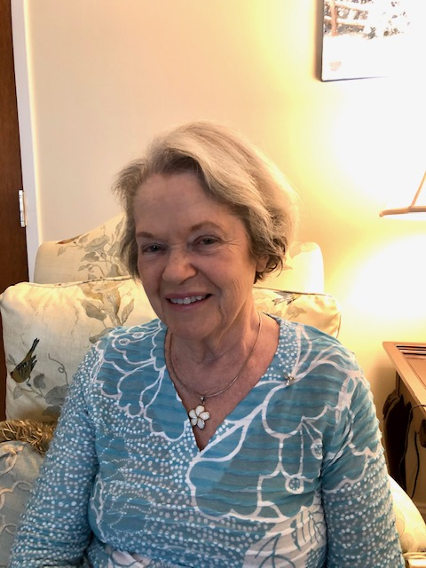 *“Feeling rather uncertain about my future life, I remembered that my husband, Joe, and I had always planned to move into Westminster Village, when the right time came. The move to Westminster was a huge decision but I am so happy to be here with such a friendly, professional, and dedicated staff. I am now happily residing here in Westminster with new friends and lovely memories. The residents are my new friends and their friendships are immeasurable to me. Westminster takes care of my needs as I am an aging resident. I pray for the staff, and residents to be healthy and enjoy their home here in lovely Westminster Village!*

**Sharon Stephen** grew up on a farm in Huntington County, which taught her a multitude of life treasures. She loved its vastness of open spaces, the beautiful fields of wheat, corn, and of course their animals. They even had three pet skunks; Inky, Winkie, and Skinky. Leaving the farm was a new experience for Sharon when she came to Muncie to attend and graduate from Ball State, with a degree in Family & Consumer Sciences. Sharon taught Science classes and Family & Consumer classes. She married Joe Stephen and they had two sons, Bradley and Stanley. Sharon feels that her life has been so blessed.

____________________________________________________________________________________________________________________

CCRC: Myth vs Fact

**Myth:** “A CCRC is the same as a Nursing Home.”

**Fact:** No, a Continuing Care Retirement Community is not a nursing home, but a nursing home is an important part of the benefits of living at a CCRC. Westminster Village offers Residential Living in apartments, Assisted Living, Rehab-to-Home, AND Skilled Nursing Care in our Health Center, all of this on 65 beautifully landscaped acres.

Westminster has consistently high-quality ratings that reflect our commitment to providing the best care for our residents, whether it is for a short-term rehab, long-term skilled care, or follow-up after a hospital stay. One of the biggest benefits of retirement living at a CCRC, such as Westminster, is that if one of our residents ever needs long-term care in our Health Center, they are assured a placement by virtue of being a resident of our community. Individuals who wish to receive the quality care provided by Westminster Village but who are not residents of our CCRC may find that there are no openings at our skilled nursing center and they may need to look elsewhere for skilled care, which can be very stressful during times of a health crisis.

Naming the New Swans

On Friday, September 18th, Tyler Ewing, Westminster’s Marketing Director, was live on Facebook to announce the names of the new swans. For a month, our residents have been coming up with names for the new pair. At the final tally, there were 45 pairs of names on the list, so Westminster residents then voted on their favorite. The names that came in third were Romeo and Juliet while the runner up names were Fred and Ginger. The winning names are…Bonnie and Clyde!!

Safe & Warm at

Westminster Village

As we approach the cooler temperatures of fall, do you have a friend or neighbor that you have concerns staying at home alone this winter? Why not talk to them about enjoying a stress-free winter with a “*Safe & Warm*” trial stay right here at Westminster Village. Imagine the freedom of a maintenance-free home, where they may choose one of our comfortably furnished apartments. No cooking necessary in one of our Kitchenette apartments where they can enjoy three meals a day or choose a Full Kitchen apartment with a One or Three Meal Plan. Amenities include activities, exercise, security and more. Westminster has no Move-in fee, Deposit or Community Fee. We are taking reservations now – Just Pack a Bag! For more information or to schedule a tour, call Tyler or Melody at 765-288-2155.

If you would like to opt out of this newsletter, please call Melody.

Westminster Village

5801 W. Bethel Avenue

765-288-2155

wvmuncie.com